
Port Dover Minor Baseball Association
1025 Main St,
Port Dover, ON
N0A 1N2
www.portdoverminorbaseball.com

Members Team Official / Volunteering

Date: ________________________________________

Please consider this letter as our confirmation to engage the following person as a Volunteer within the Port Dover Minor Baseball Association.

Full Name:_____________________________________________________________________
Date of Birth:__________________________________________________________________
Age Group and Level (ex. Rookie House, U11 Rep):_____________________________________
Team Official / Volunteer Position: __________________________________________________

The position is one of trust and authority towards vulnerable persons aged 4 through 17. Based on the position above, the individual will be in direct contact as with vulnerable persons during games and practices. We appreciate you proceeding with the Vulnerable Sector Screening Check accordingly.

Sincerely,
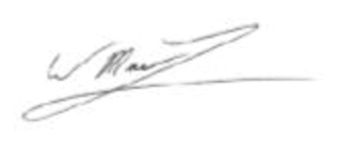
Wade MacLean, President,
Port Dover Minor Baseball Association

